PROGRESS REPORT

**Assessing the impact of substance use treatment for preventing criminal justice system contact in Chile**

# Project Overview

* **Research question**

What is the impact of SUT on preventing contact with the criminal justice system in Chile, in the short (3 and 6 months), middle (1 year), and long term (3 years)?

* **Aims**

(1) Describe the contact with the criminal justice system of the Chilean population according to the end status of their recorded treatment (i.e., early dropout, therapeutic discharge) at baseline.

(2) Estimate the short, middle, and long-term effect of SUT on the probability of contact with the criminal justice system, according to different treatment end statuses.

* **Hypothesis**

Patients who achieve treatment completion have a lower probability of being in contact with the criminal justice system compared to patients who do not complete treatment, although this effect may decrease as observation time passes (3 and 6 months, 1 year, and 3 years).

# Progress overview

In this section we described the main milestones achieved so far.

* **Data wrangling**

This research relies on a population-based record-linkage retrospective cohort design.

The data wrangling includes managing two administrative databases: (i) The first one contains information of patients receiving substance use treatment financed by the National Service on Drugs and Alcohol (SENDA) and (ii) the second database offers offending sentences information provided by the Prosecutor’s Office data at the national level.

As the SENDA database is an enhanced source (already reviewed and managed by a member of this team for previous research) most of the data managing procedures focus on the Prosecutor’s database. A detailed description (step by step) of the data wrangling of this project is available in a [data wrangling repository](https://fondecytacc.github.io/nDP/). However, the main activities completed in the last 6 months are described below.

* + *Data exploration and cleaning:* Considering all the variables available in the databases, we explored the data focusing on missing data, variance, and other descriptive measures.
  + *Data normalization:* We standardised variables, labelled fields, and corrected data integrity issues (e.g., typographical errors in dates, automation bias, or variations in name spelling or form). A consistency analysis between the two databases was checked before the databases merge process (i.e., demographic data should be the same in both sources for the same individuals wherever available). Special attention was paid to date information (such as ‘date of birth’ and ‘date of crime commission’), as they are crucial for our analysis, and we decided to apply the imputation of missing data in some cases. More information about imputation decisions is available [here](https://fondecytacc.github.io/nDP/Fiscalia_merge2.html#correct-dates).
  + *Codebook Prosecutor’s database:* We built a codebook of the Prosecutor’s database (SENDA’s dataset codebook was already available), to have a precise understanding of the data and to make our research replicable, accountable to others and to enable further research.
  + *Data linking:* We linked the two administrative databases (SENDA and Prosecutor’s Office), and the process is summarised in figure 1.

*Figure 1 Data merging process*

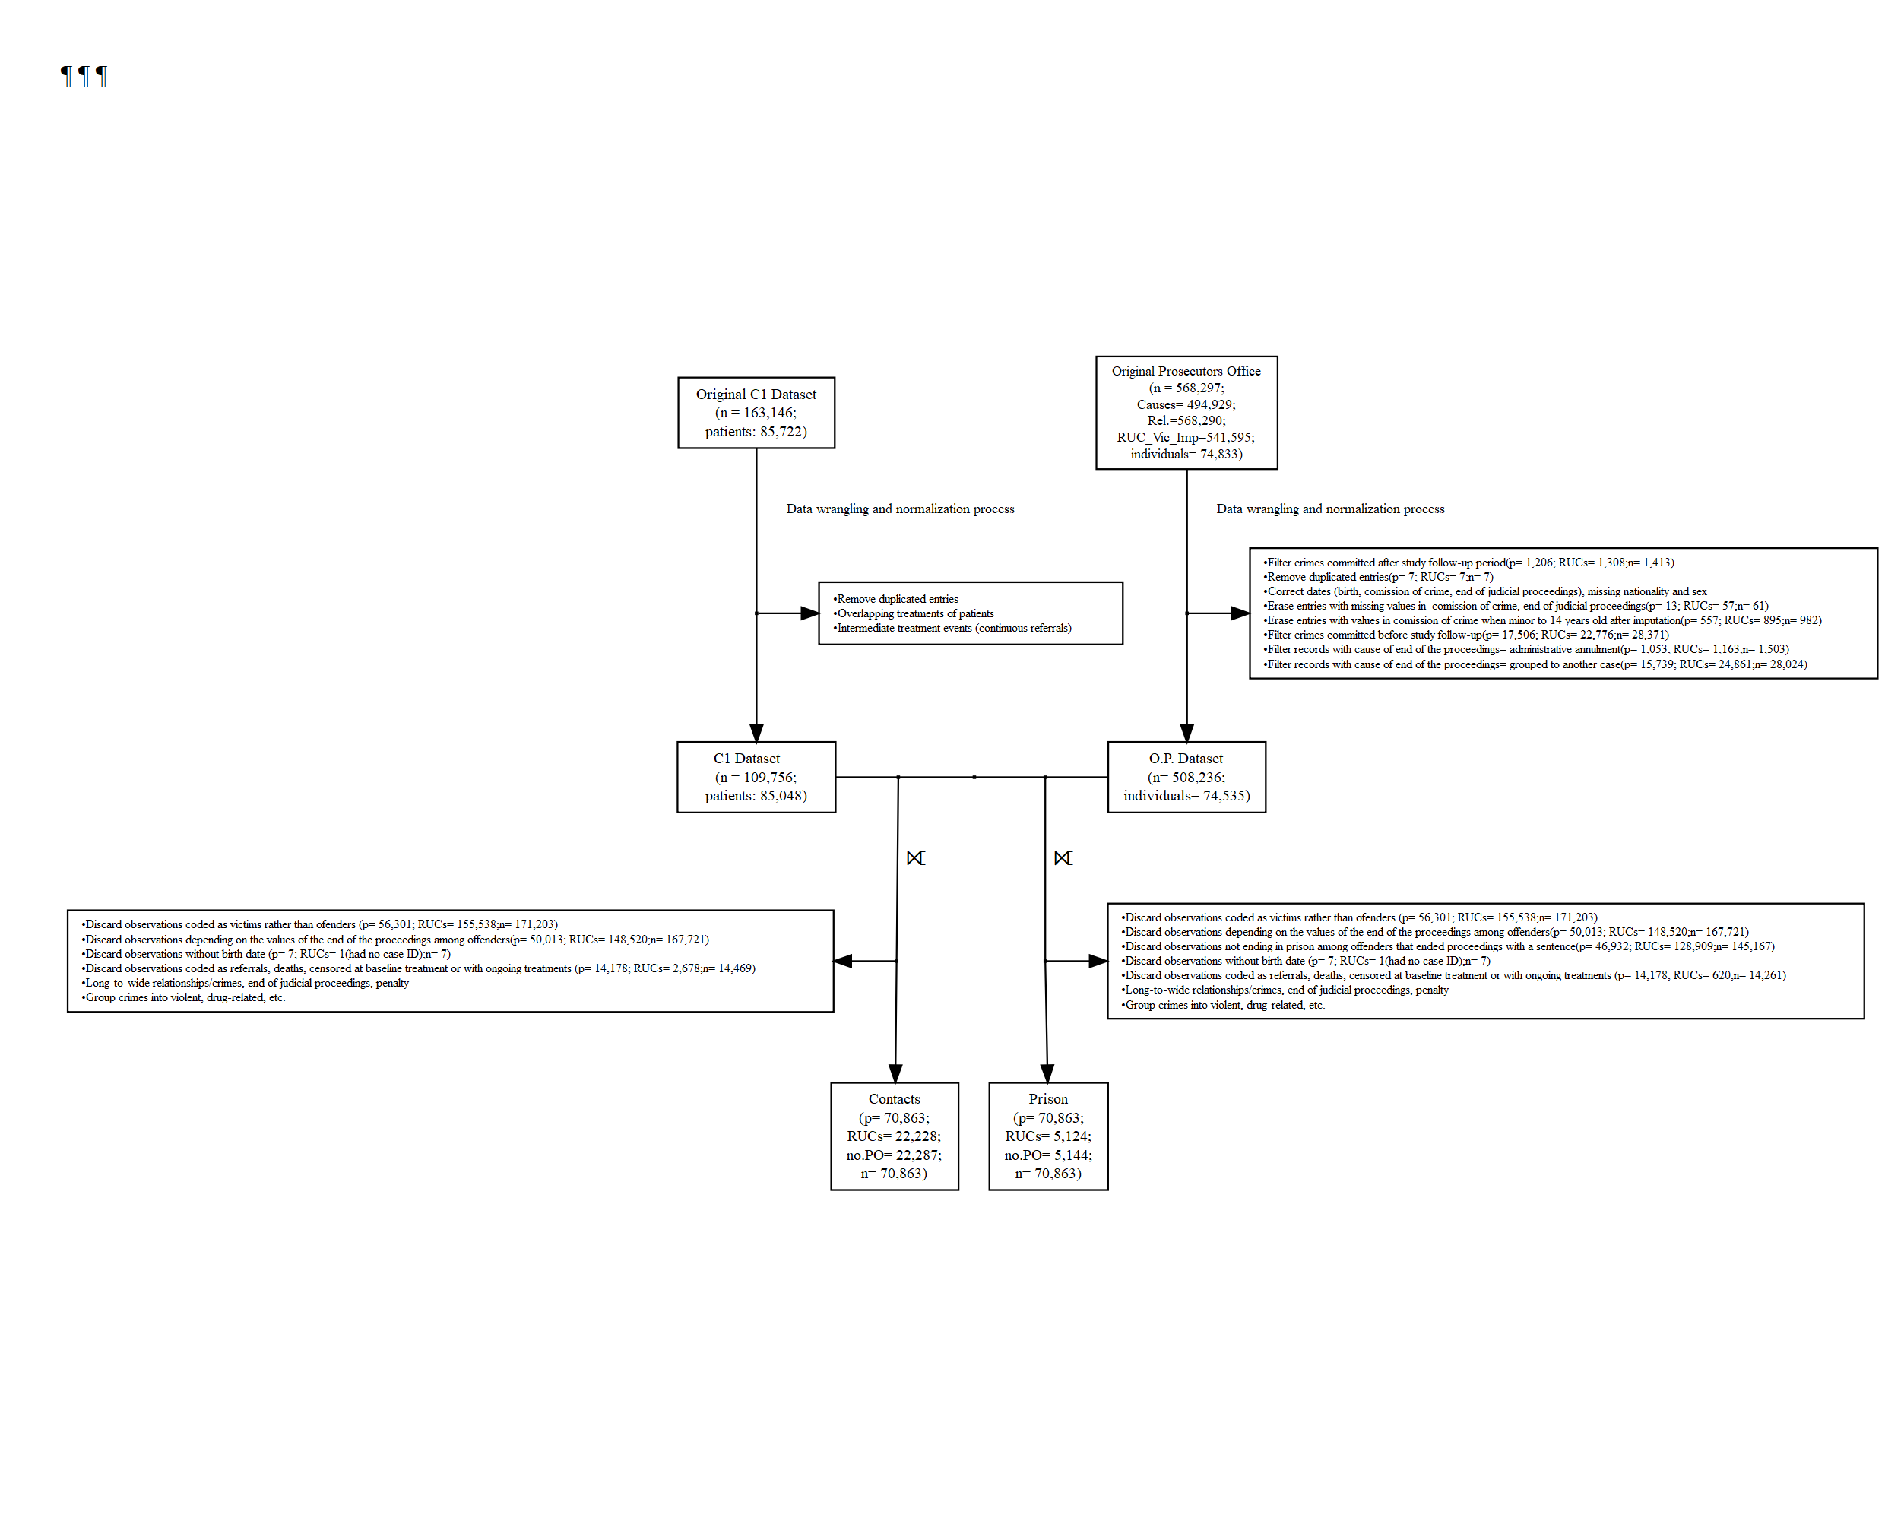

* **Ethics application**

We have applied this project to the ethics of Griffith University Human Research Ethics Committee (GUHREC), and we have received approval (GU Ref No: 2022/919). Having ethics approval is key to being able to publish our work.

* **Theoretical framework**

We have done a literature review according to the project design and the selected outcome variables. The theoretical framework progress is exposed in the next section (III). Changes to the theoretical framework will be introduced after concluding the analysis.

* **Preliminary analysis**

The main steps of the data analysis are described below.

* *Definition of outcome variables*

Having explored the data, our research team discussed the better outcomes variables considering several possibilities (i.e., type of crime, number of contacts, etc.). Finally, we decided to consider the following outcomes:

* + *Contact with the criminal justice system.* The main outcome variable is contact with the criminal justice system, which includes information on both ended proceedings through regular and diversionary criminal justice response, according to official records provided by the Chilean Prosecutor’s Office. There is a consensus that self-reported data is more accurate than other official records in estimating criminal behaviour (Havnes et al., 2012). Despite the prior limitations, the availability of official records of criminal justice contact is used as one of the few available indicators of offending in Chile at a national level. We discarded relationships in which the subject considered an offender was not the patient from SENDA. Also, we restricted the analysis to the patients that had a final judgment as guilty with a condemnatory sentence (“SENTENCIA DEFINITIVA CONDENATORIA”), compensation agreements (“ACUERDO REPARATORIO”), suspended finishing of the proceedings (“SUSPENSION CONDICIONAL DEL PROCEDIMIENTO”) and definitive dismissal (“SOBRESEIMIENTO DEFINITIVO”) provided they were nested to the Article 240 of the Civil Procedure Code.
  + *Imprisonment.* The second outcome variable considered is the first offence after substance use treatment leading to imprisonment. Focusing on this outcome implies inspecting a reduced sample subset but is valuable since the cost of imprisonment for society is enormous.
* *Data structure*

Patients’ entry to the retrospective cohort starts at the time they were admitted for the first time to a SUT listed in the SENDAs yearly databases with information of treatments between 2010-2019 (independently if they had prior treatments). We considered patients that had ongoing treatments in 2010 (e.g., patient no. 11). Censoring occurred after SENDA sent us the data (November 13, 2019), after an outcome event occurred (e.g., the blue dot after 2020), or when a patient left the cohort with no other outcomes.

* *Preliminary findings*

We have conducted a preliminary analysis to achieve our first research aim: (1) Describe the contact with the criminal justice system of the Chilean population according to the end status of their recorded treatment (i.e., early dropout, therapeutic discharge) at baseline).

Additionally, we have explored the data to pursue our second research aim: (2) Estimate the short, middle, and long-term effect of SUT on the probability of contact with the criminal justice system, according to different treatment end statuses.

The analysis progress regarding the two aims is shown in section IV.

# Theoretical Framework

The question of how substance use treatment (SUT) influences criminal behaviour is essential for implementing, evaluating, and strengthening treatment programmes and policies to tackle addiction and delinquency. Both issues are interrelated since criminal involvement and criminal networks can hinder substance use recovery, and at the same time, substance abuse can be an obstacle to desistence from crime (Gossop et al., 2005; Skjærvø et al., 2021). Moreover, it has been found that substance use treatment programmes not only have the potential to improve individual lives but also to benefit society by reducing criminal behaviour and reducing demand on the criminal justice system and the victim costs of crime (Garnick et al., 2014; Gossop et al., 2005; Smart & Reuter, 2022). Nevertheless, substance use disorders (SUD) are typically difficult to treat as relapses are common, leading to describe SUD recovery as a non-linear process (Kaskela & Pitkänen, 2020). Hence, assessing SUT outcomes is a complex task, and longitudinal and population-level studies are crucial to understand better the twists and turns of the long-term recovery process from a representative sample size.

Extensive research has assessed the effectiveness of SUT programmes on criminal outcomes through a wide range of methodologies and measures. A very well-known meta-analysis on this field was conducted by Prendergast et al. (2002). It considered 78 studies on SUT outcomes with rigorous methodological designs (i.e., experimental, or quasi-experimental) and 25 of which examined crime outcomes (including self-reported crimes and official records of arrest, conviction, and incarceration). These studies concluded that substance use treatment has a statistically significant effect in reducing substance use and criminality, estimating an average decrease in criminal involvement of 13%. Since this meta-analysis was conducted, more recent research has provided additional evidence of the effect of substance abuse treatment programmes, thus adding insights on the role of treatment retention, specific treatment settings (i.e., residential, outpatient, prison-based), approaches and substances, as well as longer-run crime-related outcomes (Bondurant et al., 2018; Oliver et al., 2010). For instance, some studies have pointed out the relevance of treatment completion. In Finland, it has been documented that discontinued inpatient treatment episodes are more likely to be followed by criminality leading to imprisonment during a 5-year follow-up period, compared with completed treatment periods (Kaskela & Pitkänen, 2020). Other observational studies have found a sustained decreased proportion of participants with heroin dependence involved in criminal activity, from 54.6% at baseline to 22.0% after an 11-year follow-up, according to the Australian Treatment Outcome Study (Teesson et al., 2015). Recent systematic reviews on the effect of heroin-dependence treatment suggest that specific treatment approaches have a different impact on decreasing criminal activity, where heroin-assisted treatment resulted in lower criminal activity compared to oral methadone treatment in the United States (Smart & Reuter, 2022). Additionally, it has been shown that follow-ups lengths have a significant impact on the conclusions obtained, as short-term (6 months or less) follow-up are likely to show better results than longer-term ones since it is estimated that 60%-80% of substance use relapses occur more often in the first three to four months following the discharge (Bondurant et al., 2018; Marsden et al., 2000). Another factor identified as a powerful predictor of poor criminal justice outcomes is criminal justice involvement before substance use treatment (Garnick et al., 2014). Together, previous research provides consistent evidence that substance use treatment programs can prevent crime. Specifically, longitudinal studies enable us to identify the extent and under which conditions these findings are valid, contributing valuable insights into treatment outcomes and how certain groups may respond differently over time (Smart & Reuter, 2022; VanGeest & Alemagno, 2017).

While these studies have made significant contributions to our knowledge, most of the prior evidence comes from developed countries and regions (e.g., the US and Western Europe), and results from the low- and middle-income contexts are largely unknown (Klingemann, 2020; Mateo et al., 2022). Using results from high-income countries can be misleading because the epidemiological, social context and substance use treatment policy responses are different. For example, prevalence rates in Latin-American tend to be lower for heroin while higher for alcohol and noninjected drugs, such as cocaine and cocaine base paste (Castro et al., 2021; Pacurucu-Castillo et al., 2019; Rehm et al, 2021). Additionally, evidence shows that local or national differences in substance availability, as well as modes and routes of administration (i.e., intravenous, smoked) of substance use, result in variations in SUD (Gorelick, 2021). Certainly, to understand these Latin American features adequately, the structural conditions of poverty and social exclusion should not be overseen, as they enable criminal behaviour and drug use in specific social sectors, such as disadvantaged neighbourhoods (Seddon, 2006).

Then, the SUT policy response is also peculiar, as it is designed considering the country-specific epidemiologic context (e.g., harm reduction or emphasis on detoxification) and economic resources, which in high-income countries has led to the development of structured intervention approaches (e.g., Cognitive-behavioural Therapy, Acceptance and Commitment Therapy) that are differentiated according to specific substances (e.g., heroin, alcohol). Therefore, most studies on SUT impact have been restricted to clinical issues addressed through randomised controlled trials or pre-post observational studies, focusing on a specific approach or a specific substance rather than larger treatment service issues (Babor, 2021). Furthermore, SUT policy specificity differs from the reality of other contexts like the Latin-American countries. Yet, the question of SUT effectiveness is still relevant to address policy decision-making. To date, there has been limited research on an integrated SUT approach across substances, longitudinal designs, large-scale samples, multi-site, or system-level treatment, as well as studies on administrative data-based outcomes (Babor, 2021; Krebs et al., 2009; Teeson et al., 2015;). This gap is even more evident in the context of low- and middle-income countries.

The Chilean SUT policy is an interesting case of study as it is one of Latin America's oldest and most developed systems (Marín-Navarrete et al., 2018). Unlike high-income countries, the Chilean SUT system employs multiple intervention approaches rather than specific interventions for particular substances. Chilean SUT programmes are provided by public and private centres and consider ambulatory and residential treatment settings for adult and adolescent populations (Mateo et al., 2022). The current research aims to examine the impact of SUT on the prevention of contact with the criminal justice system in Chile in the short (3 and 6 months), middle (1 year), and long term (3 years). To explore this, we use a retrospective cohort design, linking two administrative data sets, which include the population of people 18+ years of age in publicly funded Chilean SUT programs, with the National prosecutor’s data of all criminal causes registered for this population in the period 2010-2019.

# Preliminary analysis

We described the cumulative incidence rate and incidence rate ratio of offences that ended with a condemnatory sentence and of offences that ended with imprisonment after baseline treatment outcome, and its variation by baseline treatment outcome: Treatment completion, Late Discharge (>= 3 months) Early Discharge (withdraw within the first 3 months of treatment.

Posteriorly, we aim to calculate the association between Baseline treatment outcome and Contact with the justice system through flexible Royston-Parmar models while adjusting for several covariates, as well as using a 2-step inverse probability weighting Royston-Parmar survival regression and adjusting for covariates. Mentioned analyses are depicted in the following equations:



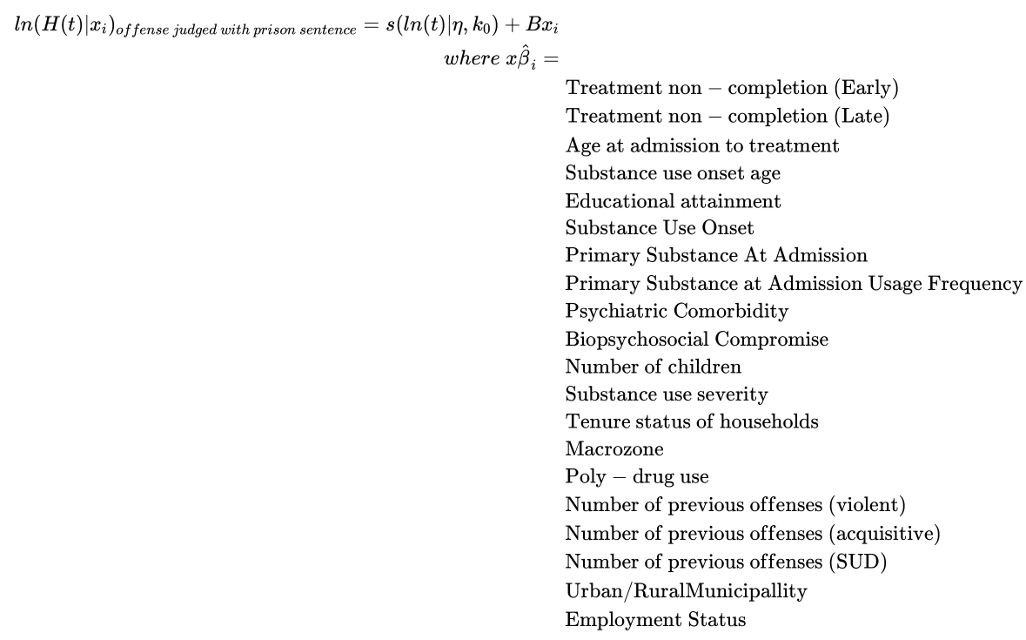

**Main findings**

* Of the 85,048 SENDA patients, 70,863 (83%) were eligible to be matched with the Prossecutor’s Office database. Of the sample, 22,287 (31%) had at least an offense that ended with a condemnatory sentence after baseline treatment (Table 1). Those that had at least an offense that ended with imprisonment after baseline treatment were 5,144 (7%) (Table 2).
* Compared to those receiving no treatment (early drop-out), those completing SUT took longer to contact the criminal justice system (IRR [Incidence rate ratio]= 2.18 95% IC 2.09,2.27) and to commit an offence leading to imprisonment 2.90 (95% IC 2.64,3.18) (Figure 2).
* Compared to receiving some treatment (late drop-out), those completing SUT took longer (IRR= 1.73 95% CI 1.67,1.80) to contact the criminal justice system and to commit an offence leading to imprisonment (IRR= 1.93 95% CI 1.77,2.10) (Figure 2).
* However, the difference was lower when we compared those who received some treatment with those who no SUT for some period (late drop-out) regarding the time to contact the criminal justice system (IRR= 1.26 95% CI 1.22,1.30) and imprisonment (IRR= 1.50 95% CI 1.41,1.61).

*Table 1 Offending with condemnatory sentence from Baseline Treatment Outcome (x1000 person-years)*

*Table 2 Offending with imprisonment from Baseline Treatment Outcome (x1000 person-years)*

*Figure 2 Cumulative Hazards of Offense from baseline treatment outcome (Staggered entry)*

* From a Cox model, the test of Schoenfeld residuals for proportional hazards for condemnatory sentence as an outcome yielded a significant score (X2(16)=144.35, p<0.001) with the following variables having deviations: age at admission, educational attainment, mental health comorbidity (ICD-10), substance use dependence (ICD-10), poly-drug use, number of previous acquisitive offenses and number of previous substance-related offenses. Also imprisonment (X2(16)=66.34, p<0.001) with the following variables having deviations: age at admission, substance use onset age, sex, educational attainment, and the number of previous substance-related offenses.
* Tested several parametric distributions and Royston-Parmar cubic spline modes in order to get the specification with the best fit to the data but more parsimonious (best fit with fewer parameters).
* We ran a model with the following independent variables
  + Baseline treatment outcome
  + Age at admission to treatment
  + Substance use onset age
  + Sex
  + Educational attainment
  + Primary substance at admission
  + Primary substance at admission usage frequency
  + Biopsychosocial compromise
  + Tenure status of households
  + Psychiatric comorbidity
  + Substance use severity
  + Macrozone
  + Poly-drug use
  + Number of previous offenses (violent)
  + Number of previous offenses (acquisitive)
  + Number of previous offenses (substance-related)
* For Condemnatory sentence, we chose a Royston-Parmar with the baseline log‐cumulative hazard modelled by restricted cubic splines (RCSs) of 10 and 4 degrees of freedom (df).
* The model with 10 df’s showed that Late discharge had 49% greater hazards of condemnatory sentence than treatment completion (HR= 1.49, 95% CI: 1.43, 1.56), while Early discharge had 52% greater hazards than treatment completion (HR= 1.52, 95% CI: 1.44, 1.61). The IPW (inverse probability weighted) model with M-estimation[1] (Woolridge, 2002; Shu, et al 2021) of the standard errors showed that not completing treatment had 49% greater hazards (HR=1.49, 95% CI: 1.43, 1.55) for patients that did not complete treatment. The last model, assuming staggered entry to the follow-up (counting process format), showed that patients who did not complete treatment had 47% greater hazards than those who completed baseline treatment (HR= 1.47 95% CI: 1.51, 1.85).
* The model with 4 df’s showed that Late discharge had 49% greater hazards of condemnatory sentence than treatment completion (HR= 1.49, 95% CI: 1.43, 1.56), while Early discharge had 52% greater hazards than treatment completion (HR= 1.52, 95% CI: 1.44, 1.61). The IPW (inverse probability weighted) model showed that not completing treatment had 49% greater hazards (HR=1.49 95% CI: 1.43, 1.55) for patients that did not complete treatment. The model with staggered entry showed that patients who did not complete treatment had 47% greater hazards than those who completed baseline treatment (HR= 1.47 95% CI: 1.41, 1.53).
* For time-to-Imprisonment, we chose a Royston-Parmar with the baseline log‐cumulative hazard modelled by restricted cubic splines (RCSs) of 10 and 4 degrees of freedom (df).
* The model with 10 df’s showed that Late discharge had 57% greater hazards of condemnatory sentence than treatment completion (HR= 1.57, 95% CI: 1.42, 1.73), while Early discharge had 78% greater hazards than treatment completion (HR= 1.78, 95% CI: 1.58, 2.00). The IPW (inverse probability weighted) model showed that not completing treatment had 67% greater hazards (HR=1.67 95% CI: 1.52, 1.85) for patients that did not complete treatment. The model with staggered entry showed that patients who did not complete treatment had 61% greater hazards than those who completed baseline treatment (HR= 1.61 95% CI: 1.45, 1.78).
* The model with 4 df’s showed that Late discharge had 57% greater hazards of condemnatory sentence than treatment completion (HR= 1.57, 95% CI: 1.42, 1.74), while Early discharge had 77% greater hazards than treatment completion (HR= 1.77, 95% CI: 1.58, 2.00). The IPW (inverse probability weighted) model showed that not completing treatment had 67% greater hazards (HR=1.67 95% CI: 1.52, 1.85) for patients that did not complete treatment. The model with staggered entry showed was not feasible. We are still researching the causes of this non-convergence.

# Next steps

* **Paper:** We have decided to submit our work to Addiction journal, which is expected on May, 2023.

We aim to select covariates adequately, grouping them according to the hypotheses and behaviour. We are still reviewing antecedents and theoretical and empirical convenience of incluiding one or another covariate. We are also Reading about Staggered entry models in which the arrival of each subject to the follow-up does not start in time 0 to account for length-biased data With nonstationary incidence times (CITA). Also, one challenge that remains unexplored is the presence of missing values and imputation methods under Missing-at random.

* **Presentation in Scientific meetings:** Our goal is to present this study at least at one international conference such as the National Institute on Drug Abuse International Forum, or similar, and in possible scientific community activities organized either by Griffith University (Australia), Universidad de Chile or other national institutions.

# References

Babor, T.F. (2021). Treatment Systems for Population Management of Substance Use Disorders: Requirements and Priorities from a Public Health Perspective. In el-Guebaly, N., Carrà Giuseppe, Galanter, M., & Baldacchino, A. M. (Eds.). (2021). Textbook of addiction treatment: international perspectives (Second). Springer. https://doi.org/10.1007/978-3-030-36391-8

Bondurant, S. R., Lindo, J. M., & Swensen, I. D. (2018). Substance abuse treatment centers and local crime. Journal of Urban Economics, 104, 124–133. <https://doi.org/10.1016/j.jue.2018.01.007>

Castro, F., Barrera M., & Marsiglia F. (2021). Cultural Adaptation of Empirically Validated Therapies for Treating Drug Dependence: International Considerations. In: el-Guebaly N., Carrà G., Galanter M., Baldacchino A.M. (eds) Textbook of Addiction Treatment. Springer, Cham.

Garnick, D. W., Horgan, C. M., Acevedo, A., Lee, M. T., Panas, L., Ritter, G. A., Dunigan, R., Bidorini, A., Campbell, K., Haberlin, K., Huber, A., Lambert-Wacey, D., Leeper, T., Reynolds, M., & Wright, D. (2014). Criminal justice outcomes after engagement in outpatient substance abuse treatment. Journal of Substance Abuse Treatment, 46(3), 295–305. <https://doi.org/10.1016/j.jsat.2013.10.005>

Gorelick, D. (2021) Cocaine Addiction and Treatment. In el-Guebaly, N., Carrà Giuseppe, Galanter, M., & Baldacchino, A. M. (Eds.). (2021). Textbook of addiction treatment: international perspectives (Second). Springer. https://doi.org/10.1007/978-3-030-36391-8

Gossop, M., Trakada, K., Stewart, D., & Witton, J. (2005). Reductions in criminal convictions after addiction treatment: 5-year follow-up. Drug and Alcohol Dependence, 79(3), 295–302. <https://doi.org/10.1016/j.drugalcdep.2005.01.023>

Havnes, I., Bukten, A., Gossop, M., Waal, H., Stangeland, P., & Clausen, T. (2012). Reductions in convictions for violent crime during opioid maintenance treatment: a longitudinal national cohort study. Drug and Alcohol Dependence, 124(3), 307–310. https://doi.org/10.1016/j.drugalcdep.2012.02.005

Kaskela, T., & Pitkänen, T. (2020). Association between the discontinuation of substance use inpatient treatment and the risk of committing a crime leading to imprisonment: a finnish registry-based 5-year follow-up. Criminal Behaviour and Mental Health : Cbmh, 31(3), 171–182. <https://doi.org/10.1002/cbm.2198>

Krebs, C., Strom, K., Koetse, W., & Lattimore, P. (2009). The impact of residential and nonresidential drug treatment on recidivism among drug-involved probationers. Crime & Delinquency, 55(3), 442–471.

Marín-Navarrete, R., Medina-Mora, M., Pérez-López, A., & Horigian, V. (2018). Development and Evaluation of Addiction Treatment Programs in Latin America. Current Opinion in Psychiatry 31.4 : 306-14. Web.

Marsden, John, Ogborne, Alan, Farrell, Michael, Rush, Brian, World Health Organization. Management of Substance Dependence Team. et al. (‎2000)‎. International guidelines for the evaluation of treatment services and systems for psychoactive substance use disorders / John Marsden ... [‎et al.]‎. World Health Organization. <https://apps.who.int/iris/handle/10665/66633>

Mateo Pinones, M.; Gonzalez-Santa Cruz, A.; Castillo-Carniglia, A. (2022) Evidence-based policymaking: lessons from the Chilean substance use treatment policy. International Journal of Drug Policy

Oliver, P., Keen, J., Rowse, G., Ewins, E., Griffiths, L., & Mathers, N. (2010). The effect of time spent in treatment and dropout status on rates of convictions, cautions and imprisonment over 5 years in a primary care-led methadone maintenance service. Addiction (Abingdon, England), 105(4), 732–9. https://doi.org/10.1111/j.1360-0443.2009.02856.x

Pacurucu-Castillo SF, Ordóñez-Mancheno JM, Hernández-Cruz A, Alarcón RD.(2019) World Opioid and Substance Use Epidemic: A Latin American Perspective. Psychiatric Research and Clinical Practice.

Prendergast, M., Podus, D., Chang, E., & Urada, D. (2002). The Effectiveness of Drug Abuse Treatment: a Meta-analysis of Comparison Group Studies. Drug and Alcohol Dependence, 53-72.

Rehm, J. r., Probst, C., L. Llamosas Falcón & Shield, K. (2021). Burden of Disease: The Epidemiological Aspects of Addiction. In el-Guebaly, N., Carrà Giuseppe, Galanter, M., & Baldacchino, A. M. (Eds.). (2021). Textbook of addiction treatment : international perspectives (Second). Springer. https://doi.org/10.1007/978-3-030-36391-8

Seddon, T. (2006). Drugs, crime and social exclusion: social context and social theory in british drugs--crime research.(author abstract). British Journal of Criminology, 46(4), 680.

Skjærvø, I., Clausen, T., Skurtveit, S., & Bukten, A. (2021). Desistance from crime following substance use treatment: the role of treatment retention, social network and self-control. Bmc Psychiatry, 21(1). https://doi.org/10.1186/s12888-021-03518-2

Smart, R., & Reuter, P. (2022). Does heroin-assisted treatment reduce crime? a review of randomized-controlled trials. Addiction (Abingdon, England), 117(3), 518–531. <https://doi.org/10.1111/add.15601>

Teesson M, Marel C, Darke S, Ross J, Slade T, Burns L, Lynskey M, Memedovic S, White J, Mills KL. (2015) Long-term mortality, remission, criminality and psychiatric comorbidity of heroin dependence: 11-year findings from the Australian Treatment Outcome Study. Addiction.  Jun;110(6):986-93. doi: 10.1111/add.12860. Epub 2015 Mar 2. PMID: 25619110.

VanGeest, J., Johnson, T. P., & Alemagno, S. A. (2017). Research methods in the study of substance abuse. Springer.

1. Sandwich Variance via M-estimation uses stack estimating equations, which can be obtained for general nonlinear models and recommended in case of unstable weights in the first step of the model (probability of being treated).